**STOCK PRICE PREDICTION APPLICATION USING LONG SHORT-TERM MEMORY NETWORK**

Giri [Kankatharan(gk304@kent.ac.uk](mailto:Kankatharan(gk304@kent.ac.uk))  
Steven Li([sl746@kent.ac.uk](mailto:sl746@kent.ac.uk))   
Rishabh [Soni(rs898@kent.ac.uk](mailto:Soni(rs898@kent.ac.uk))   
Oliver Pulley(ocp3@kent.ac.uk)

**Stock Price Prediction Using Long Short-Term Memory – 6000-word (excluding abstract, any appendices, and references)**

Giri [Kankatharan(gk304@kent.ac.uk](mailto:Kankatharan(gk304@kent.ac.uk))

Oliver [Pulley(ocp3@kent.ac.uk](mailto:Pulley(ocp3@kent.ac.uk))

Reece [Mcdermott(rm782@kent.ac.uk](mailto:Mcdermott(rm782@kent.ac.uk))

Rishabh [Soni(rs898@kent.ac.uk](mailto:Soni(rs898@kent.ac.uk))

Steven Li ([sl746@kent.ac.uk](mailto:sl746@kent.ac.uk))

Abstract

This report illustrates the stages involved in the creation of our stock price prediction program, which lets users compare the actual prices of stocks against our algorithm predicted prices of the stocks. The program achieves this output through long short-term memory network (a type of RNN). Our report begins with an introduction, background, and goals of our program, followed by our design and implementation approach to this project. Additionally, technical processes, our problems and accomplishments surrounding this project are thoroughly analysed.

CANNOT Predict future prices of stocks

Introduction – Giri

Background - Giri

Aims – Rishabh

Requirements – Rishabh

User – Reece

Automation - Steven

Design

Initial System Design - Oli

Final System Design – Rishabh

Language and Environment - Giri

Implementation

Long Short-Term Memory - Steven

API Yahoo - Giri

Our neural network needs historical data to train and learn, to predict future prices of various stock options. We decided to use Yahoo Finance to gather closing prices of stocks because it is one of the largest rich resources of financial market data and therefore it is the best option for data collection. The larger the dataset is, the more information the neural network can learn and train itself. Yahoo finance also provides real-time quotes and financial news however this project only focusses on predicting the closing prices of various stocks within the stock exchange.

TensorFlow - Giri

Will finish this off later

Plotly Dash - Giri

Plotly Dash creates data visualisation and provides user interface tools for one to interact with an application/program. In regard to this project, Plotly Dash creates a dashboard for our users to interact with our program by allowing them to input the name of the desired stock then choose the start date and end date pickers for the period that you want to run the prediction for and finally, choose the number of epochs. An epoch refers to one full cycle over a training dataset for a neural network to learn patterns from the stock data. Too few epochs can result in an underfit model, whereas too many epochs can lead to an overfit one thus the default number of epochs is set to 75 however users can choose their own number of epochs. Furthermore, the larger the epochs, longer the processing time, which varies from user to user.

Exponential Moving Average (EMA) - Rishabh or Steven

Training Loss over time – Reece

Real-time stock prediction – Giri

Neural network Training (RNN Network) - Steven and Rishabh

Simulator/Interface

Simulator or the user interface results

Testing – Oliver and Steven

We need a detailed report of testing and training in the corpus

Conclusion - Reece

Future Work – Reece and Oliver

Acknowledgements – Oliver and Reece

Bibliography

[Is Yahoo Finance Reliable? Exploring the Pros, Cons and Risks of Using Yahoo Finance for Investment Research - The Enlightened Mindset (tffn.net)](https://www.tffn.net/is-yahoo-finance-reliable/)

[Epoch Definition | DeepAI](https://deepai.org/machine-learning-glossary-and-terms/epoch)

**Appendices**

Figure 1

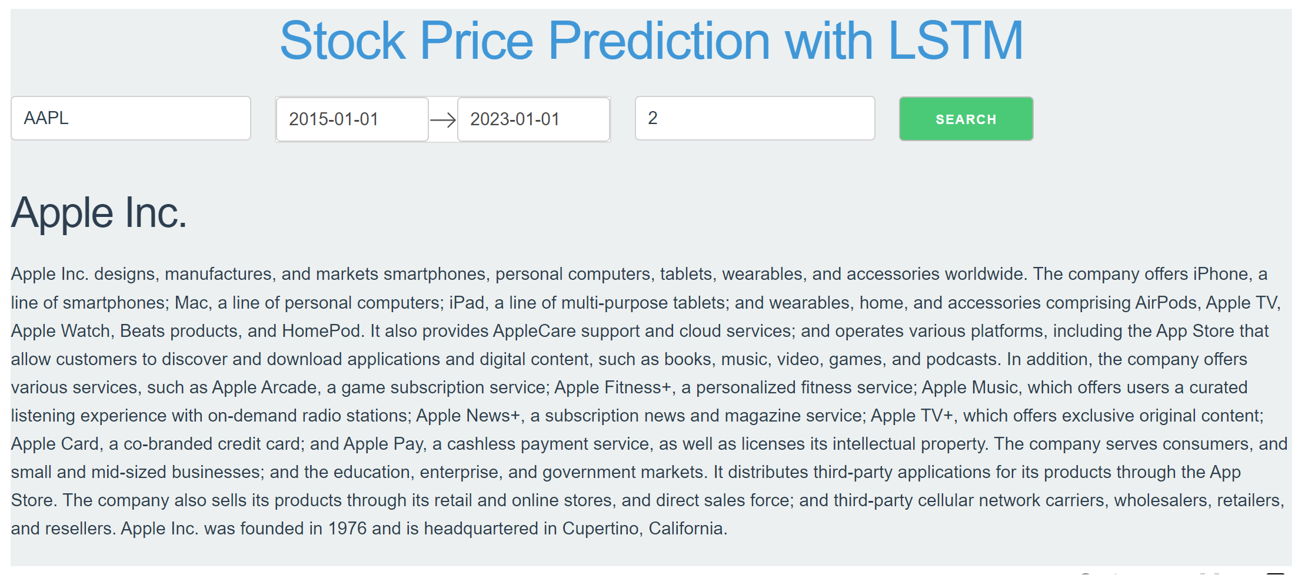

Figure 2

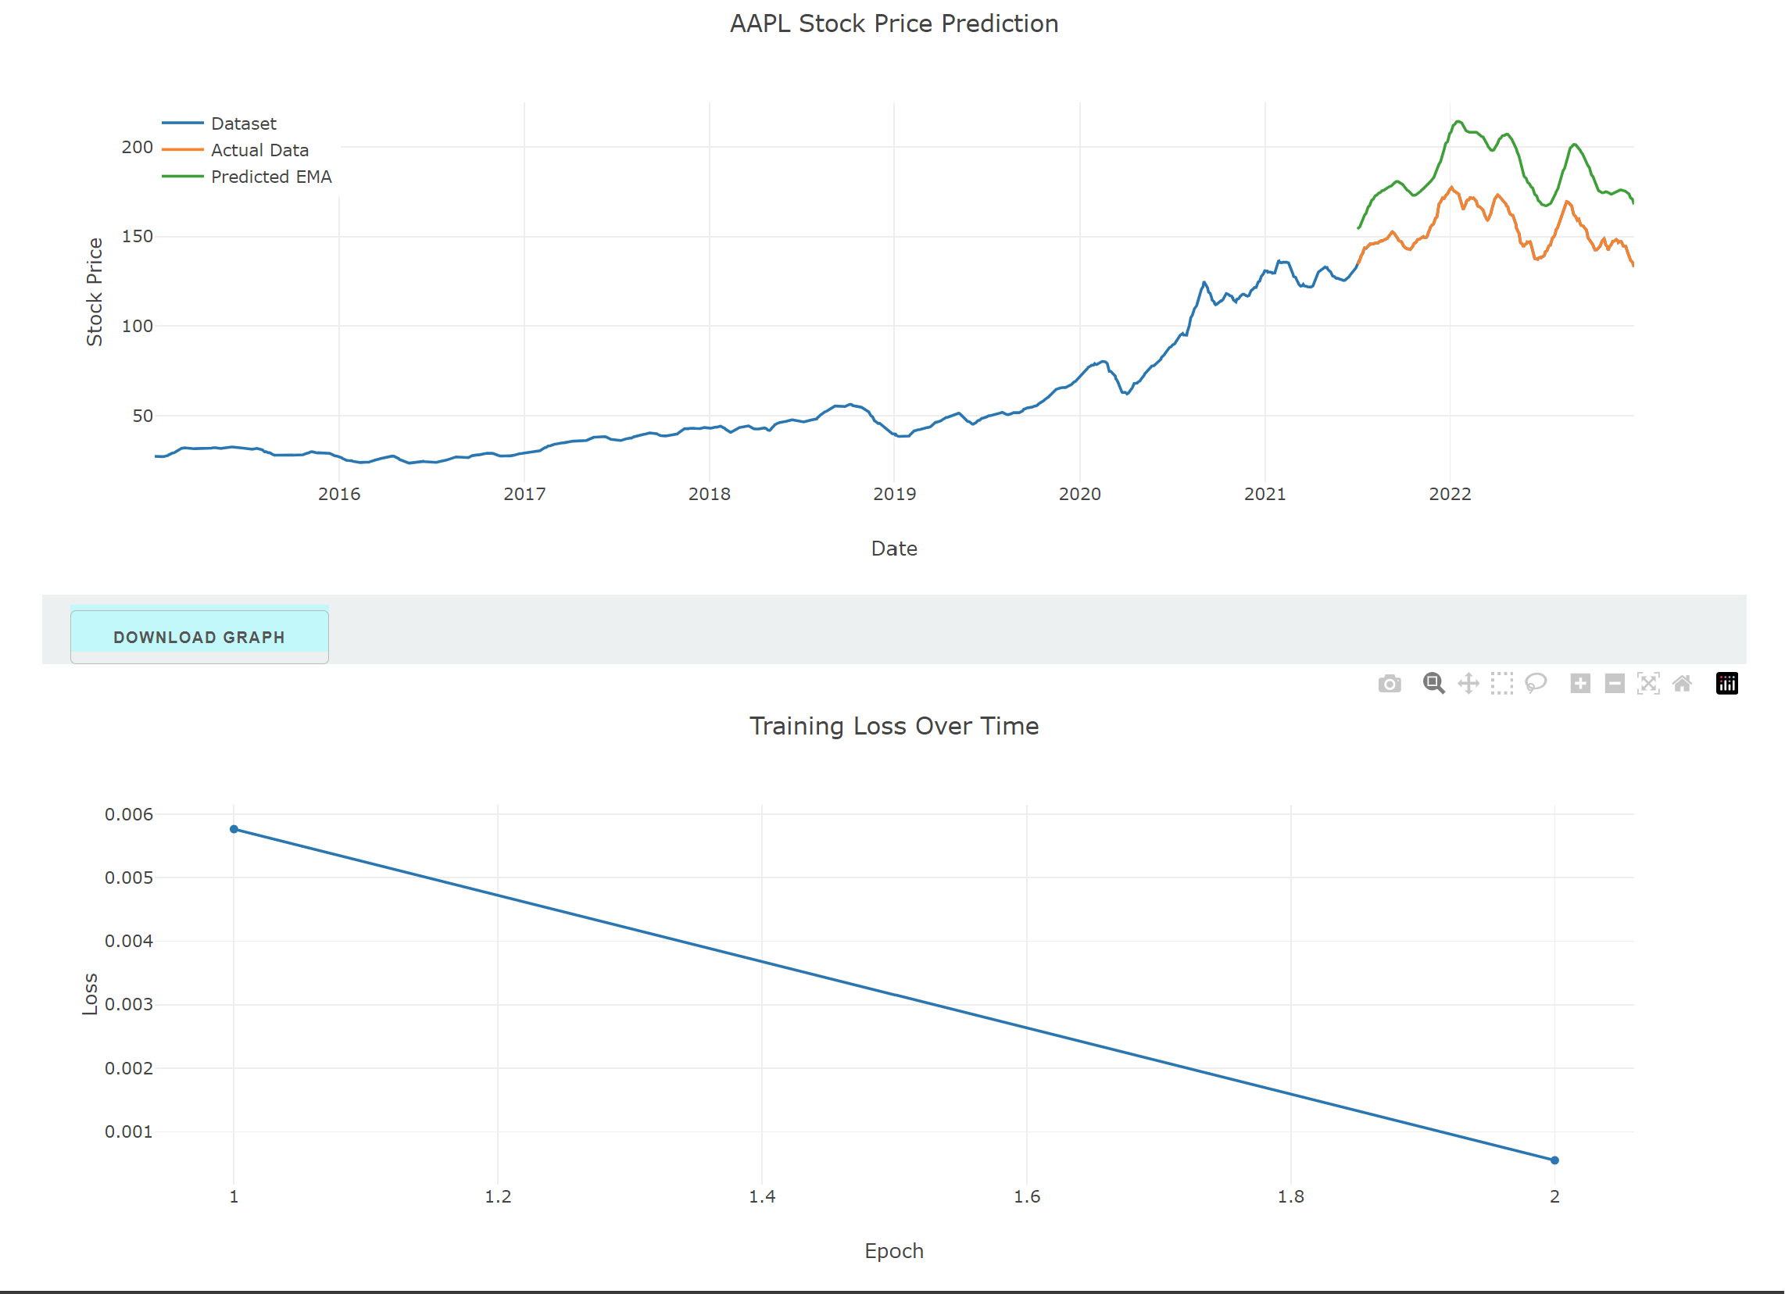

Figure 3

